UTAH LAKE WATER QUALITY STUDY

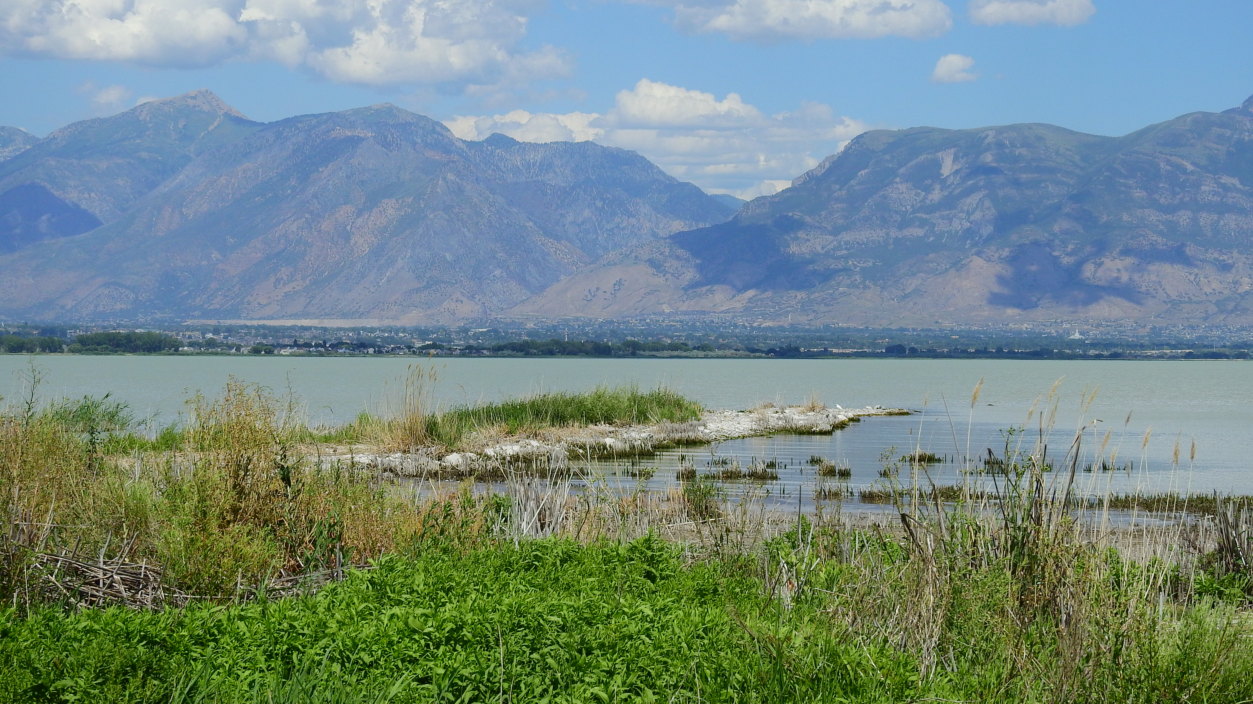
Funding

$1 million from Water Quality Board

$500,000 from Utah Legislature

Goals

Develop nitrogen and phosphorus water-quality criteria to protect the lake’s designated beneficial uses (recreation, aquatic life, and agriculture).

Develop a watershed implementation plan to achieve and/or maintain water quality levels protective of designated beneficial uses that also balances costs and benefits.

Phases

PHASE 1: Data gathering and characterization (Completed)

Establish a stakeholder process for Phase 2.

Select modeling tools for use in Phase 2.

Identify data and knowledge gaps for Phase 2.

PHASE 2: Site-specific criteria for nitrogen and phosphorus

Evaluate the factors that affect beneficial uses and contribute to harmful algal blooms in the lake.

Guide additional research to address data gaps.

Develop site-specific criteria for phosphorus and nitrogen protective of existing uses in the lake, including wildlife and recreation.

PHASE 3: Implementation planning for Phase 2 criteria

Evaluate current use designations and the scientific and economic feasibility of achieving recommended criteria.

Use water-quality and watershed models to help identify sources of phosphorus and nitrogen, reductions required to meet criteria, and inform decisions on how to best reduce nutrient loading.

Complete cost evaluation to implement required reductions.

Evaluate scenarios for achieving the most cost-effective solutions for reducing nutrient pollution.

Stakeholder Process and Structure

Steering Committee: an interest-based group representing stakeholders with a key interest in the outcomes of the study.

Science Panel: Discipline-focused group with specialized scientific expertise relevant to unique characteristics and processes in Utah Lake.

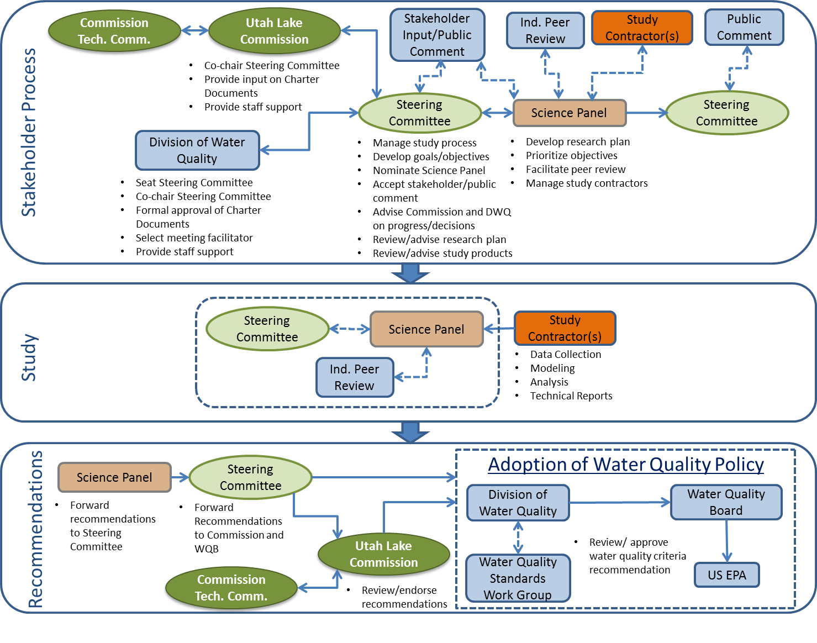

Schedule
 | 2015 | 2016 | 2017 | 2018 | 2019 | 2020 | 2021 | 2022 | 2023 | 2024 | 2025 | 2026 | 2027 | 2028 | 2029 | 2030+
Phase 1 – Data gathering and characteristics
Phase 2 – Criteria development
Phase 3 – Implementation Planning
Criteria and Implementation Plan Submittal to WQB and EPA
Nonpoint Source and MS4 Implementation
POTW Permit Implementation

